## horizontal line



DriveIn

23.07.2021

**─**

3 yoshis

NUS LifeHack 2021

# Overview

From 1940’s to the 1960s, the Drive-In Theatre was a hot spot for many. All you needed was a car and a few cents and you could stow away in a car park, enjoying the movies being played on the titan of a screen. It was a place where neighbouring cars could exchange glances or where teens could meet up when buying their food. Sadly, by the 1990’s, the popularity of such Drive-In’s severely declined. Our project - DriveIn, aims to recreate such an experience that is accessible from the click of a button.

# Goals

1. Connecting people with similar interest from everywhere and anywhere
2. Forge new friendships as well as preserve the old
3. Provide a new and unique platform for users

# Research

-Study done on 66 friends and families

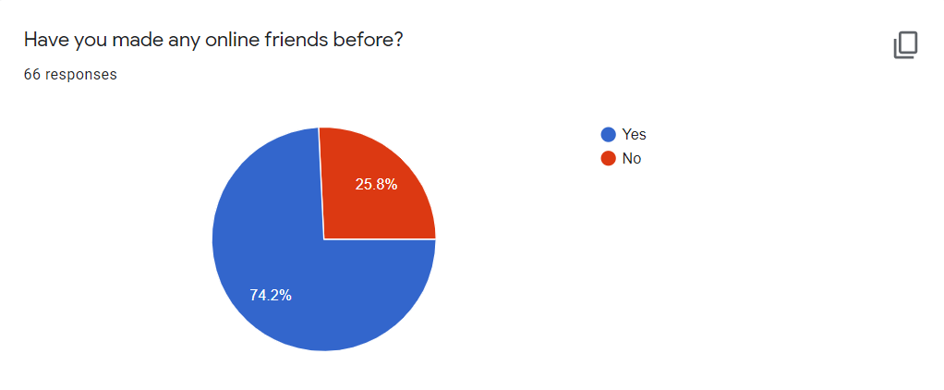

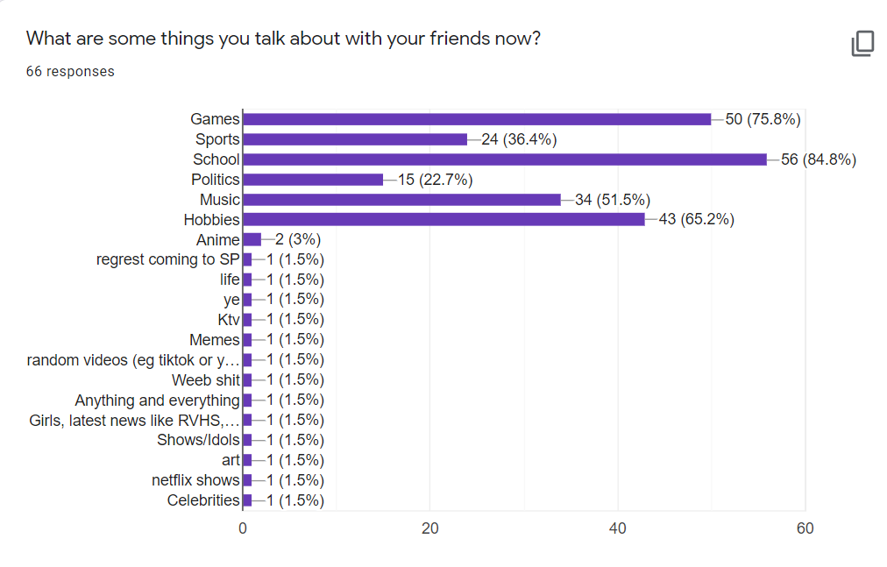

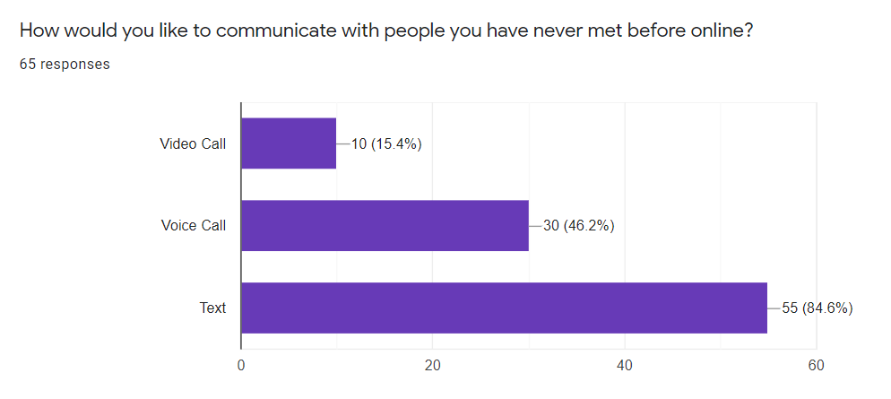

# 

# Our Idea

## General Outline

The idea that we have come up with is a text/voice based web app which allows people from all over to connect while they watch a movie or sporting event or even to learn from each other and study together.

It will be a social platform with multiple concurrent breakout rooms for different purposes, such as studying, movie room, live sports games, or other events. These rooms will have chill study music (for study rooms), or movie/ sports games streamed to the people in the breakout rooms. This would allow them to have at least something to talk about right off the bat, instead of the painstaking and dreaded small talk just to get a conversation started.

Our hope is to be able to help others to form and build long-lasting friendships which could then be taken offline when the covid measures slowly subsides all throughout the world.

## Rooms Available

In a traditional sense, Drive - Ins only display movies. However with our platform, we will have rooms for different interests. This includes, but is not limited to, sporting events, study calls or even movie nights with people. WIth variety comes options, allowing people to meet people with similar interests.

## Language based rooms

As we plan for this to be an international social platform, this means that there would inevitably be people whose native, or first, language be those not of English. To combat this, we plan to have these rooms be based on the users’ preferred language. This also gives them an opportunity to join a breakout room of a language that they may be learning and practise with native speakers.

## 

# 

# Collaboration

## Business

Our platform allows for easy collaboration with many different content creators. We are simply a canvas for studios to display and advertise their art on. This ensures sustainability for our platform.

## Social

Our platform allows us to publish pressing and important news from reliable sources such as the straits time and such. This will allow for more use for our platform, creating constant traffic and thus remaining relevant.

.